Entity Relationship Diagram (with Data Dictionary)

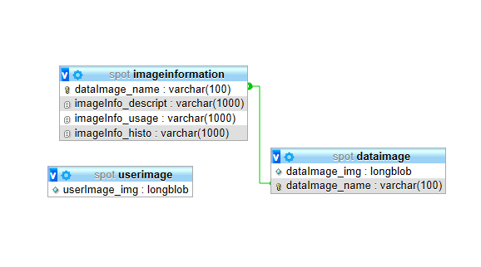

|  |  |  |  |
| --- | --- | --- | --- |
| **userImage** | | | |
| userImage_img | Not null | Longblob | User’s captured image. |

Table 2 - userImage table (ERD)

|  |  |  |  |
| --- | --- | --- | --- |
| **dataImage** | | | |
| dataImage_img | Not null | Longblob | Sets of computer related object images. |
| dataImage_name | UNIQUE | Varchar (100) | Names of each set of objects. |

Table 3 - dataImage table (ERD)

|  |  |  |  |
| --- | --- | --- | --- |
| **imageInformation** | | | |
| dataImage_name | PK/FK | Varchar (100) | Names of each set of objects in dataImage table. |
| imageInfo_descript | Not null | Varchar (1000) | Object Description |
| imageInfo_usage | Not null | Varchar (1000) | Usage of the object |
| imageInfo_histo | Not null | Varchar (1000) | Brief history of the object |